INTRODUCTION
  - Project Overview
Economic freedom plays a vital role in determining a country’s prosperity, competitiveness, and the overall well-being of its citizens. Although there is no shortage of datasets and reports, there remains a gap in interactive and comparative tools that make this information easily accessible and actionable for diverse stakeholders.
This project aims to analyze and visualize the Index of Economic Freedom across multiple countries, providing insights into how economic policies relate to national prosperity. By leveraging statistical analysis, advanced data visualization, and real-time filtering, this platform empowers policymakers, researchers, investors, and the general public to intuitively explore and interpret key economic indicators in a meaningful way.
The solution integrates data ingestion, processing, and visualization within a modular framework. It offers features such as global freedom heatmaps, year-over-year trends, top/bottom country rankings, and correlation analyses with other socio-economic metrics like GDP and unemployment rates. This project bridges the gap between raw data and informed decision-making through a transparent, scalable, and user-focused approach.
  - Purpose
The purpose of this project is to develop an accessible, data-driven platform that enables the analysis and visualization of the Index of Economic Freedom across various countries and time periods. This initiative seeks to empower policymakers, researchers, and investors by equipping them with actionable insights into how economic freedom shapes prosperity, governance, and sustainable development
By transforming complex datasets into interactive dashboards and comparative tools, the project fosters informed decision-making, promotes transparency in economic policies, and supports academic and institutional research. Ultimately, the solution aspires to highlight global economic trends and guide strategic reforms that advance economic liberty and growth worldwide..

IDEATION PHASE
  - Problem Statement

Problem Statement (PS) | I am | I’m trying to | But | Because | Which makes me feel
PS-1 | a policy | understand how | the data is | there’s no | confused
PS-1 | maker | economic freedom | complex and | simple | about
PS-1 |  | affects my country’s | spread across | and | making
PS-1 |  | growth | many reports | interactiv | policy
PS-1 |  |  |  | e platform | decisions

PS-2 | a student | study economic freedom trends in different countries | I can’t compare trends across quarters and states | there’s no visual tool to compare indicators | stressed and lost during research
PS-3 | an investor | Find which countries have good  economic conditions | current reports are hard to read and not  interactive | there’s no clear dashboard with insights | unsure where to invest wisely
PS-4 | a researcher | link economic freedom to other factors like GDP or employment | I can’t filter and see connections quickly | tools are static and not interactive | slowed down and stuck

  - Empathy Map Canvas
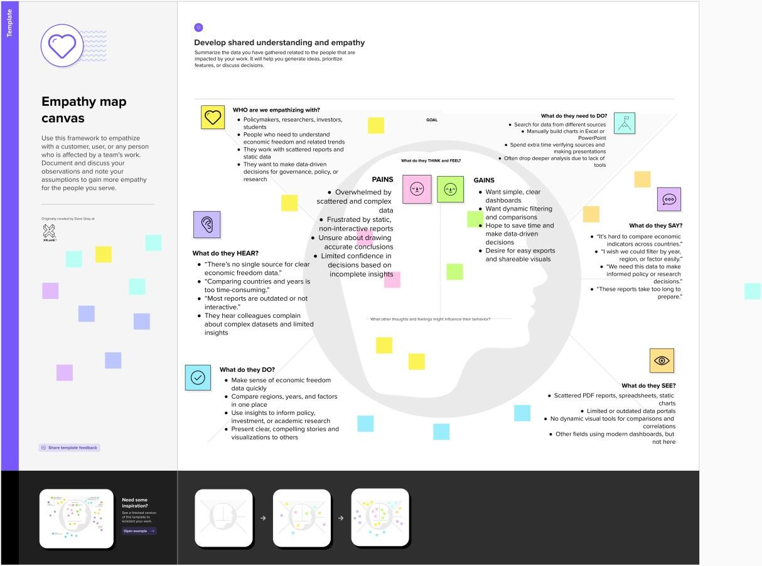

Yipoyinaka oka

  - Brainstorming
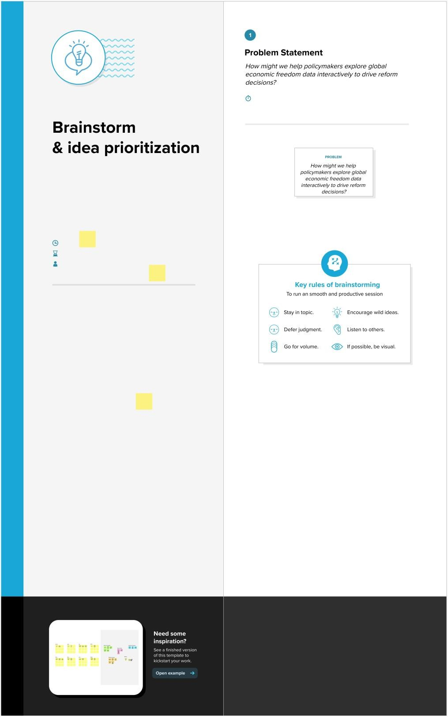

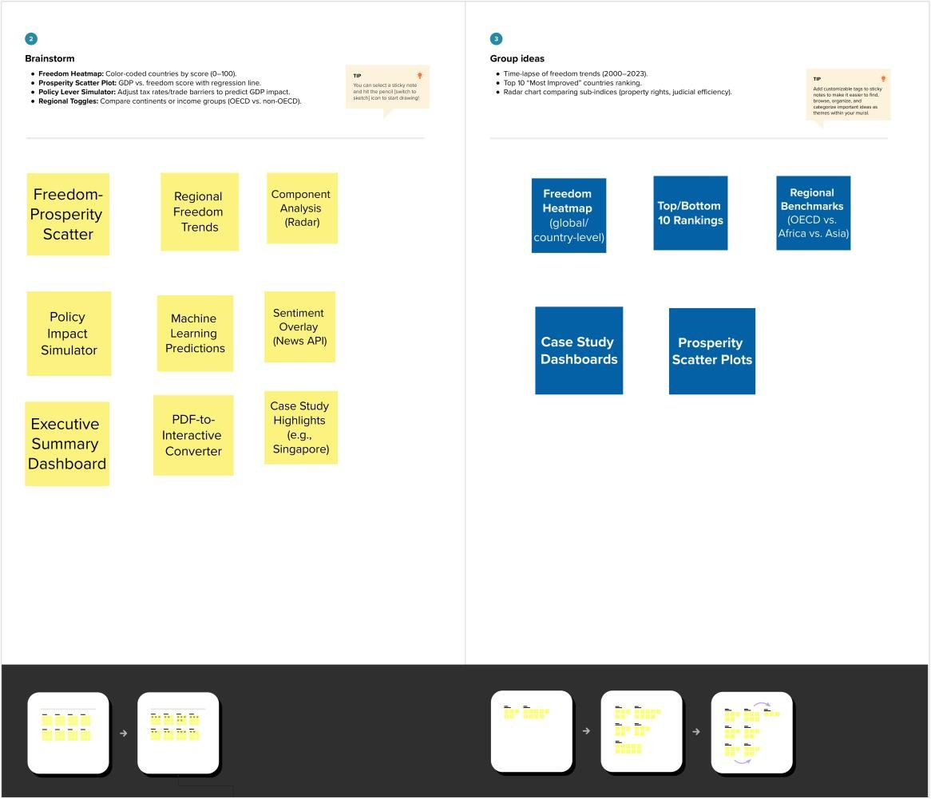

REQUIREMENT ANALYSIS
  - Customer Journey map

Stage | Need | Action | Touchpoint | Pain Point | Opportunity
Discover | Wants to understand economic  trends | Searches reports and articles | Government sites, PDF’s | Data is scattered and outdated | Unified interactive dashboard
Explore | Needs country wise & yearly comparision | Browses charts manually | Spreadsheets, reports | Time-consum ing & repetitive | Filter-enabled economic freedom  platform
Engage | Wants to correlate economic freedom with GDP | Tries to merge datasets | Manual calculations | Lacks easy correlation tools | Pre-built correlatio n & trend visualizati  ons
Decide | Prepares reports for staakeholders | Screenshots graphs | Presentations, PDFs | Lacks storytelling & clarity | Use Tableau story points with captions

  - Solution Requirement Functional Requirements:
Following are the functional requirements of the proposed solution.

FR  No. | Functional Requirement (Epic) | Sub Requirement (Story / Sub-Task)
FR-1 | Interactive KPI Dashboard | Displays revenue, units sold, active users, and discount percentage filtered by year and region.
FR-2 | Correlation & Comparative Analysis | Allows users to compare economic freedom with GDP,  employment, and other socio-economic factors.
FR-3 | Time-Series  Visualization | Shows annual trends and changes in economic freedom  using line and bar charts.
FR-4 | Indicator Drill-Down Insights | Provides detailed views for sub-indices like trade freedom, tax burden, and regulatory efficiency.
FR-5 | Geo-Map Representation | Visualizes regional economic freedom across countries or continents using heatmaps.
FR-6 | Story-Based Dashboard Navigation | Sequential story view explaining economic freedom analysis with narrative captions.

Non-functional Requirements:
Following are the non-functional requirements of the proposed solution.

FR  No. | Non-Functional Requirement | Description
NFR- 1 | Performance | Dashboards must load within 3–5 seconds even with filters applied.
NFR- 2 | Scalability | The framework should support future data addition (e.g., new models or regions).
NFR- 3 | Responsiveness | Dashboard layout should be usable on laptops and projectors during presentations.
NFR- 4 | Performance | The interface must be simple, readable, and require no technical background to explore.
NFR- 5 | Usability | Use a dark theme with eye-comfort colors and clear legends to reduce user fatigue.
NFR- 6 | Data Accuracy | Ensure calculations (KPIs, averages, comparisons) are correctly validated against source files.

  - Data Flow Diagram

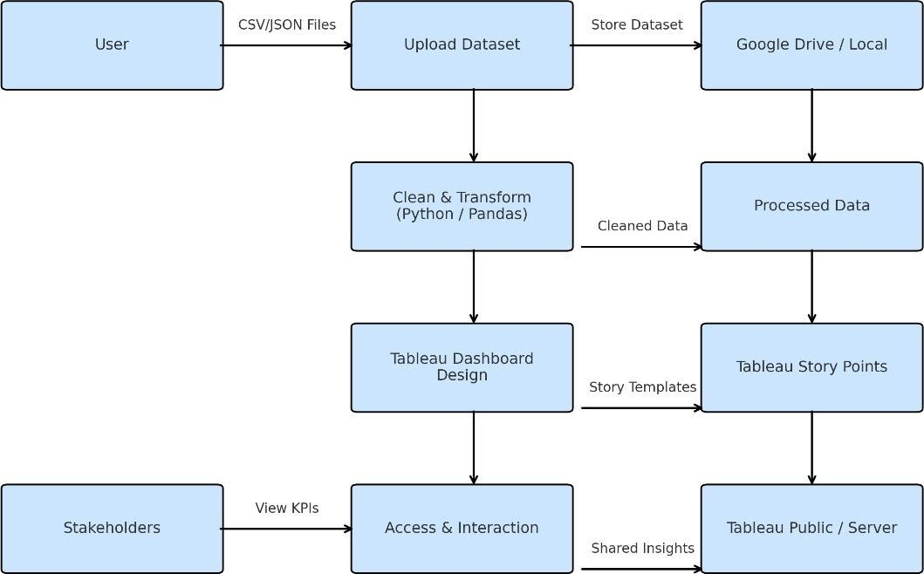

  - Technology Stack

Component | Tool/Technology | Purpose
Data Source | CSV, JSON files | Raw smartphone sales and specs data
Visualization | Tableau Desktop | Creating interactive dashboards and stories
Storage | Google Drive / Local | Storing raw and processed datasets
Collaboratio n | Google Docs, Slack | Team communication and report writing
Deployment | Tableau Public / Server | Dashboard sharing and stakeholder access

PROJECT DESIGN
  - Problem Solution Fit

Policymakers, researchers, investors, and students struggle to access and interpret economic freedom data because it is scattered across multiple reports, lacks interactivity, and is not easily comparable across countries or time periods. This makes it difficult to understand how economic freedom influences prosperity, governance, and growth.

Solution:
The proposed solution provides an interactive, user-friendly dashboard that consolidates global economic freedom data into one accessible platform. It offers dynamic visualizations, time-series trends, correlation tools, and geo-maps that help diverse stakeholders explore, compare, and analyze key indicators easily. By transforming complex datasets into clear, actionable insights, the solution bridges the gap between raw data and informed decision-making — empowering evidence-based policy, research, and investment.

  - Proposed Solution

S.No. | Parameter | Description
1. | Problem Statement (Problem to be solved) | Policymakers, researchers, investors, and students lack a centralized, interactive way to explore and compare economic freedom data across countries and time periods. Data is scattered and often static, making it hard to draw meaningful,  timely insights for informed decisions.
0. | Idea / Solution description | Development of an intuitive, interactive economic freedom dashboard with easy-to-use filters for country, year, and sub- indices. Clean, accessible visualizations and a clear layout make insights understandable for technical and non-technical users alike. Includes modern color schemes and export features for reports.
0. | Novelty / Uniqueness | Unlike traditional static reports, this solution uses dynamic dashboards with real-time filtering, comparison, and correlation analysis. Users can explore relationships between economic freedom and other indicators like GDP or unemployment, which are  difficult to see in static data.
0. | Social Impact/ Customer Satisfaction | Supports evidence-based decision-making, encourages transparency in economic governance, and empowers researchers and students to better understand prosperity trends. Reduces time spent searching for scattered data, improving productivity and data  literacy.

0. | Business Model (Revenue Model) | Can be offered as a subscription-based research tool for think tanks, universities, or government bodies. Consultancy services can help customize the dashboard for specific regions or  additional indicators.
0. | Scalability of the Solution | The dashboard framework is scalable for additional countries, regions, and related economic indices. Only new datasets need to be added — the interactive visualizations and logic remain reusable  across contexts and research domains.

  - Solution Architecture
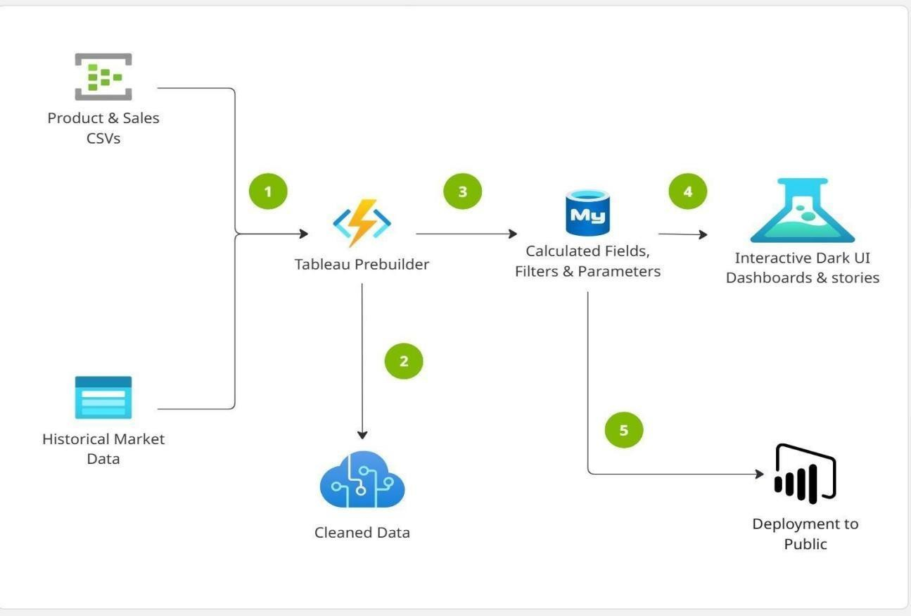

PROJECT PLANNING & SCHEDULING
  - Project Planning

Sprint | Functional Requirement (Epic) | User Story Number | User Story / Task | Story Points | Priority | Team Members
Sprint- 1 | Data Collection | USN-2 | As a user, I can load data into the processing environment | 1 | High | ALL
Sprint- 2 | Data Preprocessing | USN-3 | As a user, I can handle missing values in the dataset | 3 | Medium | ALL
Sprint- 2 | Data Preprocessing | USN-4 | As a user, I can encode or map categorical variables appropriately | 2 | Medium | ALL
Sprint- 3 | Making Graphs/Visualizations | USN-5 | As a user, I can build the initial model based on processed data | 5 | High | ALL
SPRINT  - 4 | Dashboard & STORIES | USN - 6 | Dark ui with eye feasted color palette | 6 | HIGH | ALL
SPRINT  - 5 | Report & documentation | USN - 7 | Thestep-by-step guide documentation | 7 | MEDIUM | ALL

FUNCTIONAL AND PERFORMANCE TESTING
  - Performance Testing

S.No. | Parameter | Screenshot / Values
1. | Data Rendered | Rendered from cleaned CSV files with country-wise economic freedom scores, GDP, employment rates, and other socio- economic indicators. Loaded ~1,000+ rows covering multiple  countries and years.
0. | Data Preprocessing | Handled missing values; mapped features for sub-indices like trade freedom, tax burden, and regulatory efficiency; categorized regions and time periods for consistency.
3. | Utilization of Filters | Applied filters for Country, Region, Year, Economic Sub-Index, GDP, and Unemployment Rate. Dashboard remains responsive under 3 seconds for smooth user interaction.
4. | Calculation fields Used | - Average Economic Freedom Score by Region  - Year-on-Year Change Percentage  - GDP vs. Freedom Correlation Metric  - Unemployment Rate Trends  - Index Rankings & Score Bands
5. | Dashboard design | No of Visualizations / Graphs - 4 Dashboards
6 | Story Design | No of Visualizations / Graphs - 1 Stories with 2 story points each

RESULTS
  - Output Screenshots DASHBOARDS:
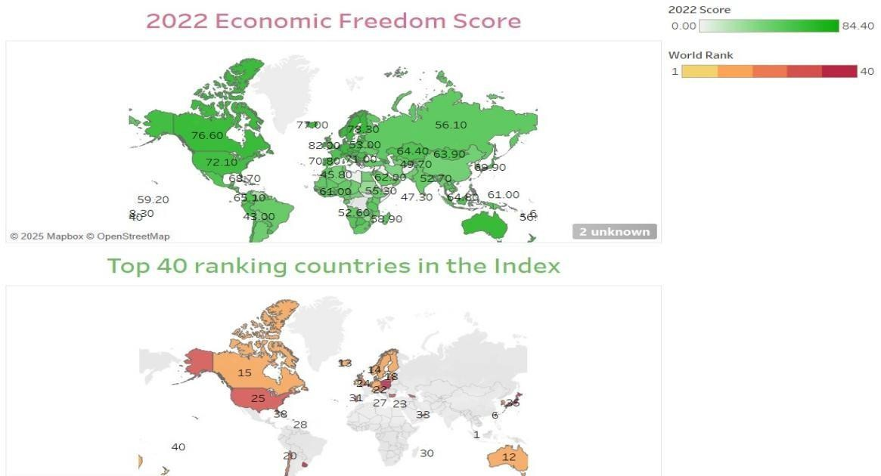

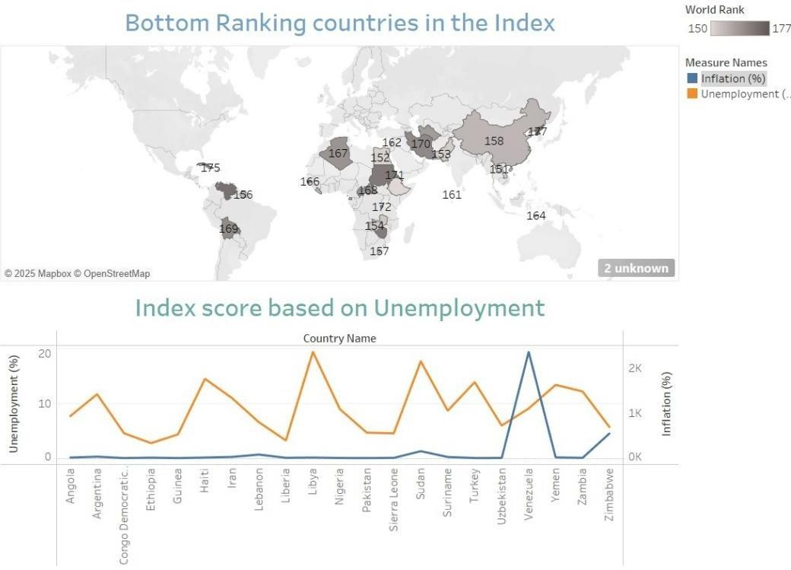
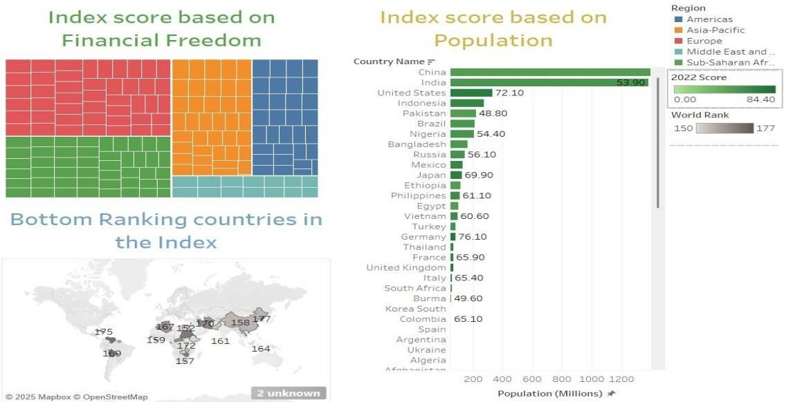
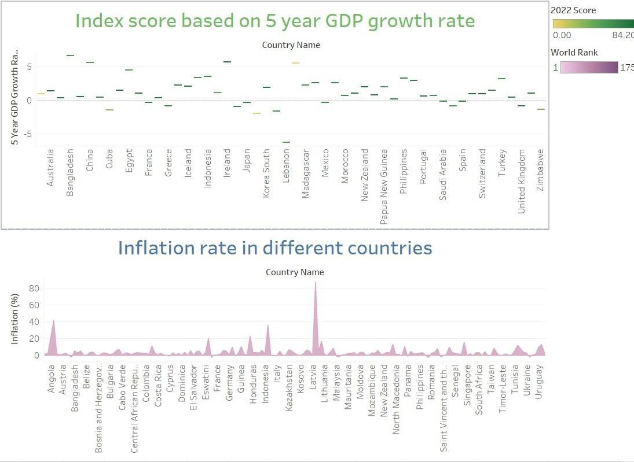

STORY 1 OUTPUTS:
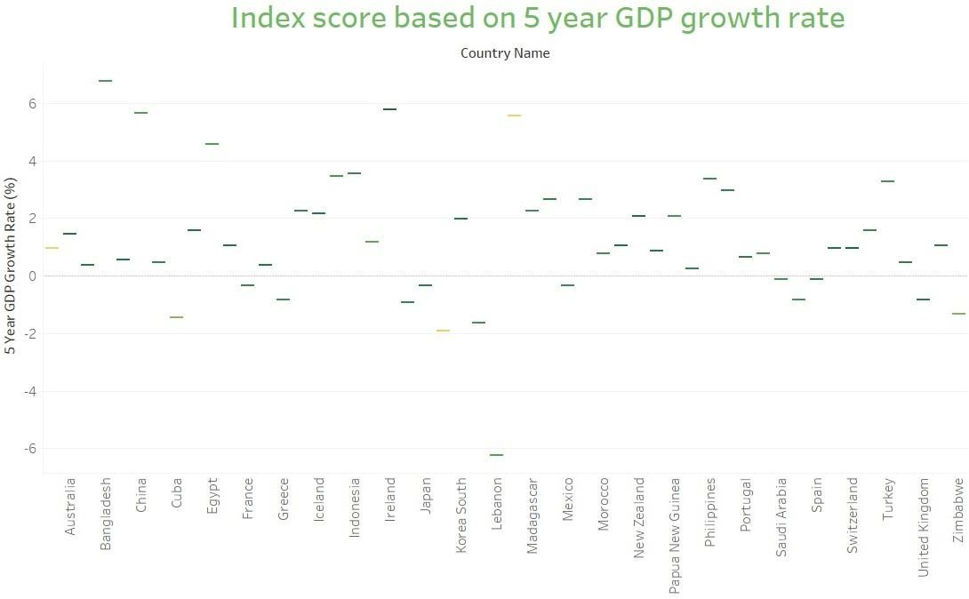

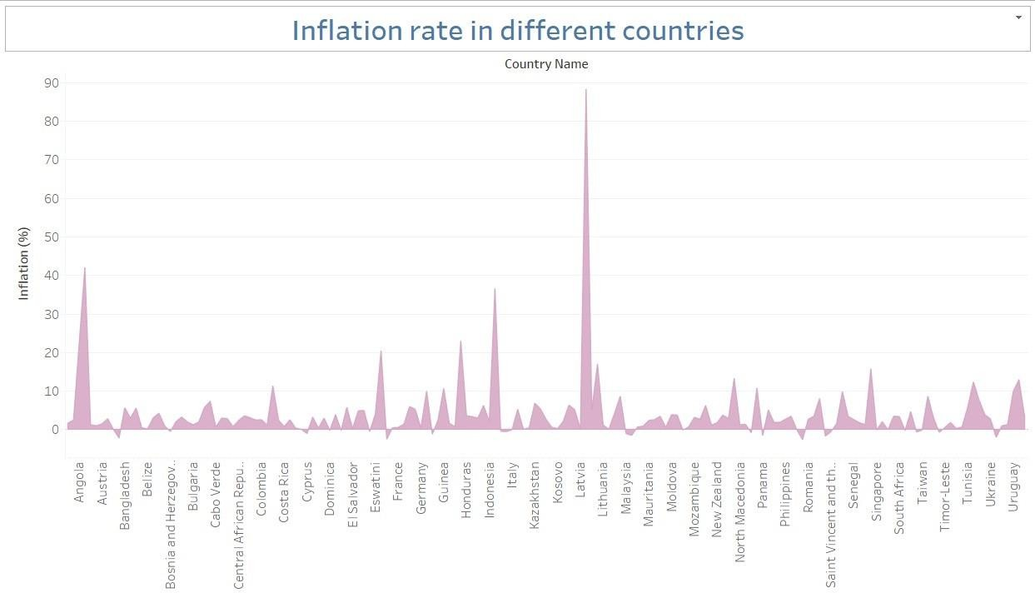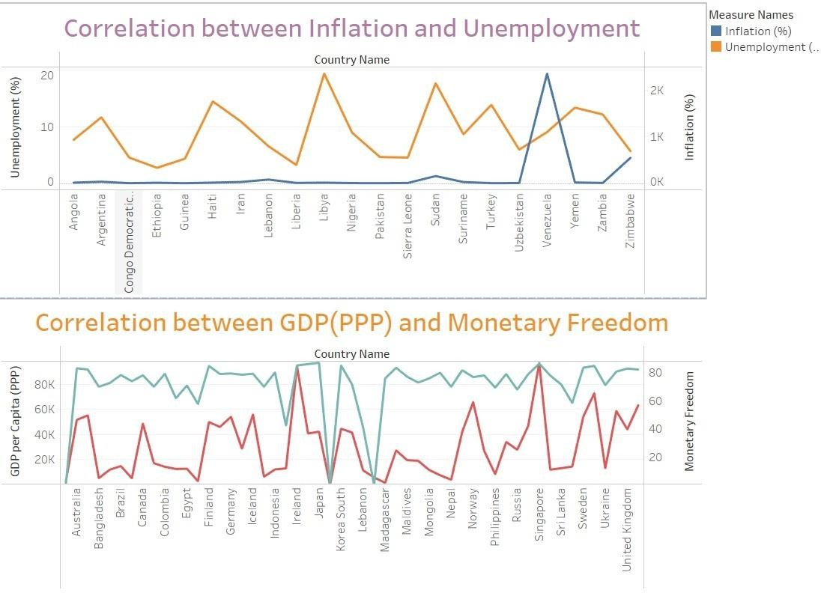

STORY 2:
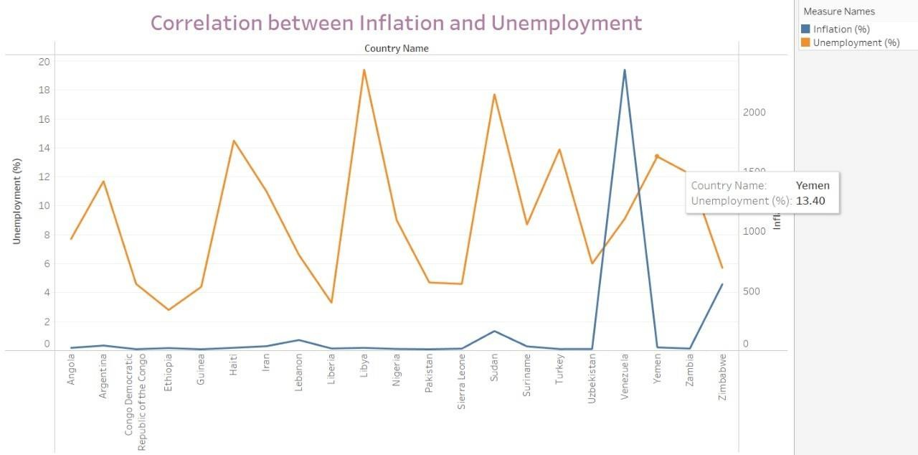
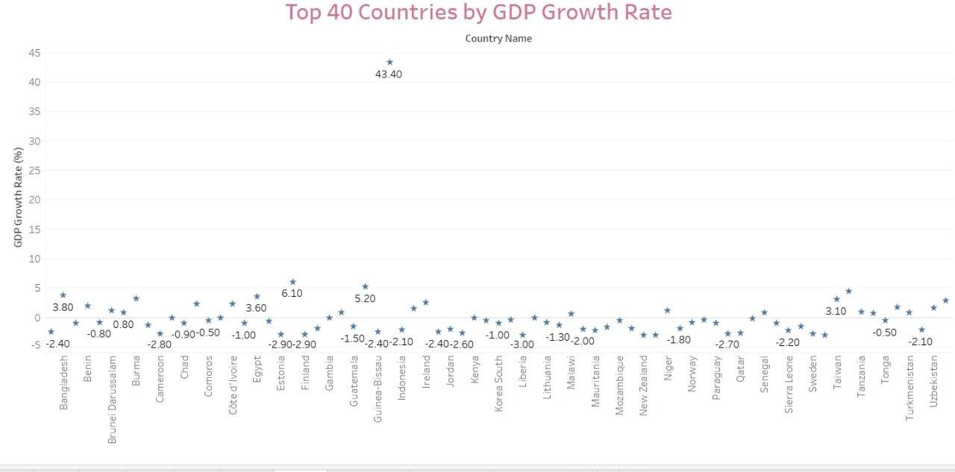

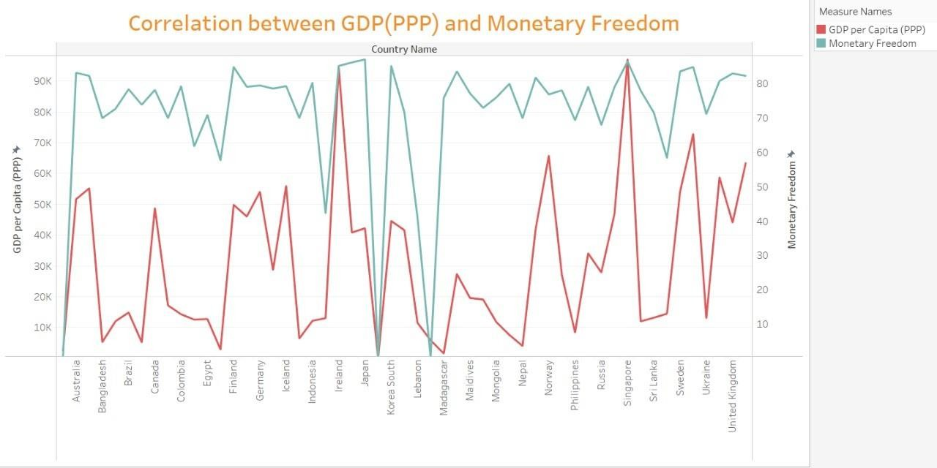

- ADVANTAGES & DISADVANTAGES

ADVANTAGES:
  - User-Friendly Dashboards: Intuitive interface with dark-themed visuals that reduce eye strain and enhance readability.
  - Interactive Insights: Real-time filtering and data slicing allow users to extract exactly what they need without manual intervention.
  - Reusable Framework: The dashboard model can be reused for other smartphone brands or markets by simply updating the dataset.
  - Data-Driven Decision Making: Helps strategists, marketers, and executives make smarter, evidence-based decisions.
  - Time-Saving: Reduces the manual workload for analysts by providing ready-to-explore visualizations.

DISADVANTAGES:
  - Platform Limitation: Tableau Public may limit some functionality such as real-time backend connection and publishing privacy.
  - Dependence on Data Accuracy: Insights are only as good as the quality of input data; inaccurate or outdated datasets could mislead.
  - Static Structure in Story: While dashboards are interactive, Tableau stories have limited flexibility in dynamic narration.

CONCLUSION
The project *“Measuring the Pulse of Prosperity: An Index of Economic Freedom Analysis”* demonstrates how data analytics and visualization can turn complex economic data into clear, actionable insights. By using open-source tools and interactive dashboards, it bridges the gap between raw data and user-friendly interpretation.
This solution helps policymakers, researchers, and investors understand global economic trends, spot policy gaps, and make informed decisions. Features like filtering, correlation analysis, and exportable visuals make the system adaptable and practical for diverse needs.

Overall, this initiative builds a strong foundation for exploring how economic freedom impacts prosperity—supporting better governance, smarter investments, and a deeper understanding of the global economic landscape.

FUTURE SCOPE
- Integration with Additional Indicators:
Expand the platform to include more socio-economic metrics like income inequality, education levels, health indices, and environmental sustainability.

- Real-Time Data Feeds:
Implement real-time or more frequent data updates by integrating APIs from trusted global economic databases.

- Predictive Analytics:
Add forecasting models to predict future economic freedom trends and their impact on prosperity.
- Custom Reports & Alerts:
Enable users to set up automated reports and notifications for significant changes in economic freedom indices.

APPENDIX
Dataset Link

https://drive.google.com/file/d/1fKRA3agI2g9Otj84zCbslKp3-zc29XTq/view?usp=sharing

